**Linear Algebra**is one of the key mathematical disciplines that work with vectors, matrices, and linear equations. It is the most widely used mathematical concept all around the world. There are several disciplines which include physics, engineering, computer science, economics, and others that use Linear Algebra as a key tool. The primary focus of linear Algebra is on linear transformations which are functions that map one vector space to another while maintaining the vector space’s structure. Matrix, which are rectangular arrays of integers, may be used to depict these transformations.

**Why we learn linear algebra:**

Linear algebra plays an important role to determine unknown quantities. Linear Algebra basically used for calculating speed, Distance, or Time and It is also used for projecting a three-dimensional view into a two-dimensional plane, handled by linear maps. It is also used to create ranking algorithms for search engines such as Google.

In computer science, algebra is used to create and solve equations that simulate the computer systems. These equations can be applied to create original algorithms or to improve system performance. In computer science, algebra is also used to represent and work with data structures.

**Vectors, combining and scaling**

**What is a vector?**

Vector is a physical quantity that has both direction and magnitude. In other words, the [vectors](https://byjus.com/maths/vectors/)are defined as an object comprising both magnitude and direction. It describes the movement of the object from one point to another. The below figure shows the vector with head, tail, magnitude and direction.

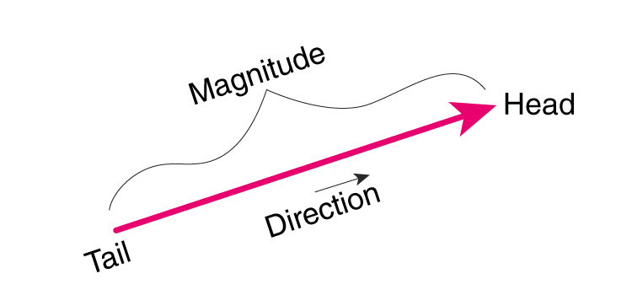

There are 10 different types of vectors that are generally used in math and science. The various vector types that are covered here are as follows.

**Types of Vectors List**

There are 10 types of vectors in mathematics which are:

1. [Zero Vector](https://byjus.com/#Zero-Vector)
2. [Unit Vector](https://byjus.com/#Unit-Vector)
3. [Position Vector](https://byjus.com/#Position-Vector)
4. [Co-initial Vector](https://byjus.com/#Coinitial-Vector)
5. [Like and Unlike Vectors](https://byjus.com/#Like-and-Unlike-Vectors)
6. [Co-planar Vector](https://byjus.com/#Coplanar-Vector)
7. [Collinear Vector](https://byjus.com/#Collinear-Vector)
8. [Equal Vector](https://byjus.com/#Equal-Vector)
9. [Displacement Vector](https://byjus.com/#Displacement-Vector)
10. [Negative of a Vector](https://byjus.com/#Negative-of-a-Vector)

All these vectors are extremely important and the concepts are frequently required in mathematics and other higher-level science topics.

**Vectors, Combining and Matrices**

Scalar quantities that have the same physical units can be added or subtracted according to the usual rules of algebra for numbers. For example, a class ending 10 min earlier than 50 min lasts [latex] 50\,\text{min}-10\,\text{min}=40\,\text{min} [/latex]. Similarly, a 60-cal serving of corn followed by a 200-cal serving of donuts gives [latex] 60\,\text{cal}+200\,\text{cal}=260\,\text{cal} [/latex] of energy. When we multiply a scalar quantity by a number, we obtain the same scalar quantity but with a larger (or smaller) value. For example, if yesterday’s breakfast had 200 cal of energy and today’s breakfast has four times as much energy as it had yesterday, then today’s breakfast has [latex] 4(200\,\text{cal})=800\,\text{cal} [/latex] of energy. Two scalar quantities can also be multiplied or divided by each other to form a derived scalar quantity. For example, if a train covers a distance of 100 km in 1.0 h, its speed is 100.0 km/1.0 h = 27.8 m/s, where the speed is a derived scalar quantity obtained by dividing distance by time.

Many physical quantities, however, cannot be described completely by just a single number of physical units. For example, when the U.S. Coast Guard dispatches a ship or a helicopter for a rescue mission, the rescue team must know not only the distance to the distress signal, but also the direction from which the signal is coming so they can get to its origin as quickly as possible. Physical quantities specified completely by giving a number of units (magnitude) and a direction are called **vector quantities**. Examples of vector quantities include displacement, velocity, position, force, and torque. In the language of mathematics, physical vector quantities are represented by mathematical objects called**vectors** ([**(Figure)**](https://courses.lumenlearning.com/suny-osuniversityphysics/chapter/2-1-scalars-and-vectors/#CNX_UPhysics_02_01_dog)). We can add or subtract two vectors, and we can multiply a vector by a scalar or by another vector, but we cannot divide by a vector. The operation of division by a vector is not defined.

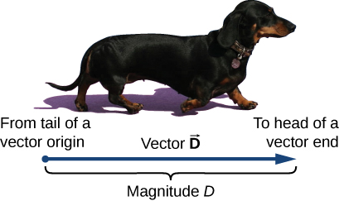

**Figure 2.2** We draw a vector from the initial point or origin (called the “tail” of a vector) to the end or terminal point (called the “head” of a vector), marked by an arrowhead. Magnitude is the length of a vector and is always a positive scalar quantity. (credit: modification of work by Cate Sevilla)

Let’s examine vector algebra using a graphical method to be aware of basic terms and to develop a qualitative understanding. In practice, however, when it comes to solving physics problems, we use analytical methods, which we’ll see in the next section. Analytical methods are more simple computationally and more accurate than graphical methods. From now on, to distinguish between a vector and a scalar quantity, we adopt the common convention that a letter in bold type with an arrow above it denotes a vector, and a letter without an arrow denotes a scalar. For example, a distance of 2.0 km, which is a scalar quantity, is denoted by *d* = 2.0 km, whereas a displacement of 2.0 km in some direction, which is a vector quantity, is denoted by [latex] \overset{\to }{d} [/latex].